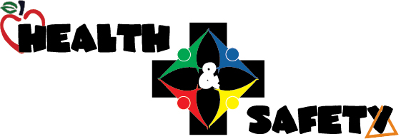

The Joint Health and Safety Committee Updated May 2026

Paul Williams 519-284-3620
Mallory De Leon 519-284-1400 x231 226-750-2287
Kim Monden 519-284-1400 x222 519-440-6253
Mel Thomson 519-284-1400 x 234 519-949-0950
Jennifer Lamondin 519-572-1588
Gavin Rawalay 226-261-3206

