Support Workers  Part Time & Full Time  Hours of work include days, afternoons, weekdays and weekends  with potential of working in both St.Marys and Stratford | - Job Posting  - •  - Posted: Nov 2, 2018
Do you enjoy working with people? Do you want a meaningful career that strives to make a difference by working toward a better, more inclusive world? If so, this job is for you. If you are energetic, positive, respectful, creative, open to learning about and creating meaningful opportunities in the community for the people you support, and are accountable to people and their families, then we would love to meet with you! Experience is great, but we will also train the right candidate. Developmental Support Work is a truly rewarding career where you will support people to engage in all aspects of life. Note that work hours do include a variety of different shifts, which will include both weekdays AND weekends. New grads and people returning to the workforce are welcomed to apply.  We Have:  - Competitive starting wage of $20.08/hr  - Flexible hours, full time employee benefits, and EAP benefits for both full time and part time staff  - ‘Compass Training’: agency philosophy around how we support people, importance of language, relationships, planning services, and medication administration.  - Employer RRSP matching program  - Ongoing education/training opportunities  You Have:  - A belief and respect for human rights  - A respect for all citizens and their right to make their own choices  - A belief that people with disabilities can be full citizens of their community  - A demonstrated ability in core competencies including: advocating for others, collaborating, problem solving and decision making, fostering independence in others, taking initiative, interpersonal relations and respect, and resilience  - An ability to work flexible hours, based on support needs  - A current, valid driver’s license, and access to a reliable vehicle  Educational Requirements:  - Ontario Secondary School Diploma or equivalent  - Preference given to candidates with post-secondary education in DSW/human services  - Note: While transcripts are not required for the interview, they are mandatory prior to any offer of employment | How to Apply:  Apply with cover letter and resume by Nov 15, 2018 at 8am to the Hiring Committee by email: hrclsma@clstmarys.ca.  Please indicate in your cover letter if you are seeking part or full time hours.  We thank all applicants, however only those selected for an interview will be contacted.  No phone calls please.  Current First Aid/CPR, Police Vulnerable Sector Check, valid Ontario ‘G’ license and access to a reliable vehicle with insurance coverage is required for all employees.  In accordance with the Accessibility for Ontarians with Disabilities Act, 2005, Community Living St. Marys & Area will make every effort to accommodate applicants with disabilities in its recruitment process.  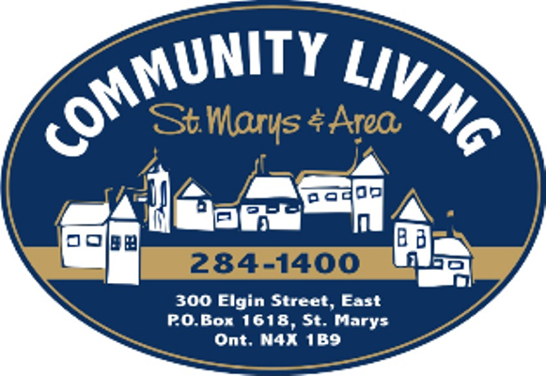  Our Mission: To nurture the ability and willingness in our community to welcome and support all people as valued and contributing citizens.

