Support Worker  FULL Time Permanent  Hours of work will include a variety of day and evening shifts, to include weekdays and every other weekend, approximately 33-35 hrs/week | - Job Posting  - •  - Posted: Aug 31, 2018
We are looking for a full time Support Worker to work with three people in St.Marys/Stratford. Two men in Stratford, and one woman in St.Marys have unique interests including comic books, Star Trek, having philosophical conversations, and being outdoors/walking in the community. As well, all love their furry companions! Do you share any of these interests and/or are open to exploring them? Are you looking for a meaningful career? If so, we encourage you to apply now!  We have:  - Competitive wages ($20.08-$22.35/hr)  - Flexible hours, a full time extended health care benefit plan, and EAP benefits for all staff  - ‘Compass Training’: agency philosophy around how we support people, importance of language, relationships, planning services, and medication administration.  - Exploration of your own Core Gift  - A commitment to staff development/training opportunities  You Have:  - Experience/willingness to learn ipad/iphone communication technology  - Experience/willingness to learn how to support people who use assistive devices including wheelchairs, lifts, etc.  - Experience/willingness to provide personal care supports  - A belief and respect for human rights and respect for all citizens and their right to make their own choices  - A belief that people we support can be full citizens of their community  - A demonstrated ability: advocating for others, collaborating, problem solving and decision making, fostering independence in others, taking initiative, interpersonal relations and respect, and resilience  - A current, valid driver’s license, and access to a reliable vehicle  Educational Requirements:  - Ontario Secondary School Diploma or equivalent  - Preference given to candidates with post-secondary education in DSW/human services  - Note: While transcripts are not required for the interview, they are mandatory prior to any offer of employment | How to Apply:  Apply with cover letter and resume by Sept 10, 2018, 8am to the Hiring Committee by email: hrclsma@clstmarys.ca  We thank all applicants, however only those selected for an interview will be contacted.  Current First Aid/CPR, Police Vulnerable Sector Check, valid Ontario ‘G’ license and access to a reliable vehicle with insurance coverage is required for all employees.  In accordance with the Accessibility for Ontarians with Disabilities Act, 2005, Community Living St. Marys & Area will make every effort to accommodate applicants with disabilities in its recruitment process.  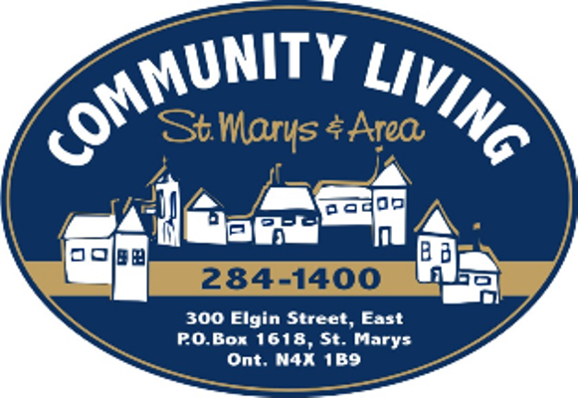  Our Mission: To nurture the ability and willingness in our community to welcome and support all people as valued and contributing citizens.

