Full Time  Overnight Support Worker  approximately 30 hrs/week  Will include every other weekend | - Job Posting  - •  - Posted: Feb 27, 2019
Are you a natural night owl? Are you looking for a meaningful career? Are you someone who is passionate about human rights? If so, this job might be for you! Two men in Stratford are seeking an overnight support worker to support them to be safe and well during the night. Overnight shifts are a combination of sleep/awake time.  We Have:  - Competitive training and starting wages  - Extended health care benefits package for FT staff  - Flexible hours, and EAP benefits for all staff  - ‘Compass Training’: agency philosophy around how we support people, importance of language, relationships, planning services, and medication administration.  - Ongoing opportunities for training/education  You Have:  - A belief and respect for human rights  - A respect for all citizens and their right to make their own choices  - A belief that people we support can be full citizens of their community  - A demonstrated ability in core competencies including: advocating for others, collaborating, problem solving and decision making, fostering independence in others, taking initiative, interpersonal relations and respect, and resilience  - An ability and desire to work flexible hours (including evenings and weekends)  - A current, valid driver’s license, and access to a reliable vehicle  Educational Requirements:  - Ontario Secondary School Diploma or equivalent  - Preference given to candidates with post-secondary education, ideally in DSW/human services  - Note: While transcripts are not required for the interview, they are mandatory prior to any offer of employment | How to Apply:  Apply with cover letter and resume by 8am, Mar 8 2019, to the Hiring Committee by email: hrclsma@clstmarys.ca  We thank all applicants, however only those selected for an interview will be contacted. NO PHONE CALLS PLEASE.  Current First Aid/CPR, Police Vulnerable Sector Check, valid Ontario ‘G’ license and access to a reliable vehicle with insurance coverage is required for all employees.  In accordance with the Accessibility for Ontarians with Disabilities Act, 2005, Community Living St. Marys & Area will make every effort to accommodate applicants with disabilities in its recruitment process.  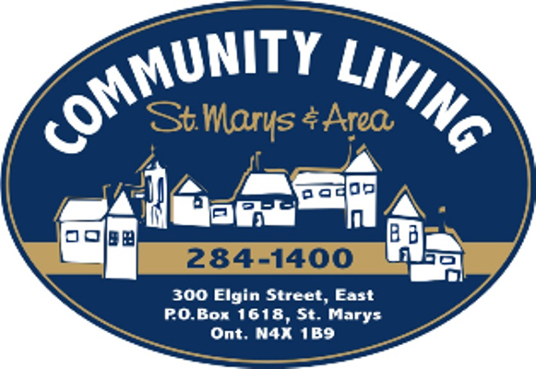  Our Mission: To nurture the ability and willingness in our community to welcome and support all people as valued and contributing citizens.

